2. User Stories and Sprints
2.2 Sprint 1 User Stories
The goal of Sprint 1 is to implement the basic functions of the reservation system, including logging in with university accounts, checking room availability, submitting laboratory qualification certificates, and reserving rooms.
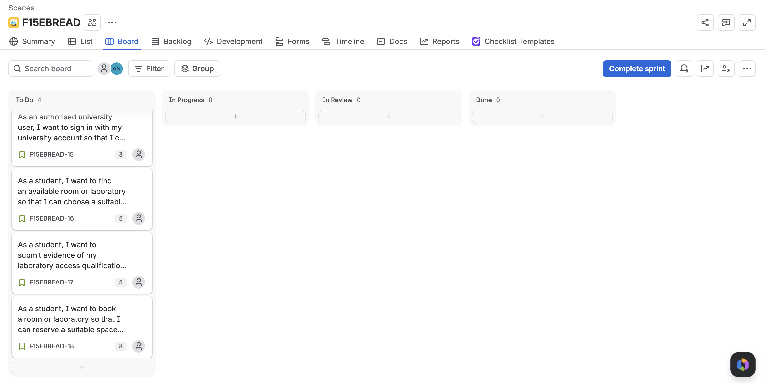

F15EBREAD-15 University SSO sign-in
User story:
As an authorised university user, I want to sign in with my university account so that I can securely access the services available to me.

Acceptance Criteria:
- A user with a valid university account can sign in.
- The user is shown the functions available to their assigned role.
- An unauthorised or inactive user cannot access the system.
- The user can securely sign out of the system.
Story Points: S

F15EBREAD-16 Find an available space
User story:
As a student, I want to find an available room or laboratory so that I can choose a suitable space and time for my activity.

Acceptance Criteria:
- The student can view rooms and laboratories available for a selected date.
- The student can view the location, capacity and relevant details of each space.
- Booked, closed and otherwise unavailable periods are clearly identified.
- The student can filter spaces using criteria such as location or capacity.
- Availability is updated when a booking or room status changes.
Story Points: M

F15EBREAD-17 Submit laboratory qualification evidence
User story:
As a student, I want to submit evidence of my laboratory access qualification so that I can demonstrate my eligibility to book a restricted laboratory.

Acceptance Criteria:
- The student can view the qualification evidence required for a laboratory.
- The student can submit the required qualification information or supporting evidence.
- A submission with missing required information is not accepted.
- The student can view whether the evidence is Pending Verification, Verified, Rejected or Expired.
- The student cannot change a verification result recorded by an administrator.
Story Points: M

F15EBREAD-18 Request a booking
User story:
As a student, I want to book a room or laboratory so that I can reserve a suitable space for my activity.

Acceptance Criteria:
- The student can select a room, date, start time, end time and booking purpose.
- A restricted laboratory can be requested only when the student has current Verified qualification evidence.
- A request that violates a booking rule or conflicts with an unavailable period is rejected with a clear reason.
- A valid request receives a booking reference and an appropriate approval status.
- The request appears in the student’s personal booking area.
Story Points: L
The story points of sprint 1 account for one-third of the total story points of the entire project.

2.3 Product Backlog
The following story has not yet been assigned to sprint 2 or sprint 3. The team will make subsequent plans based on customer feedback and project priorities.
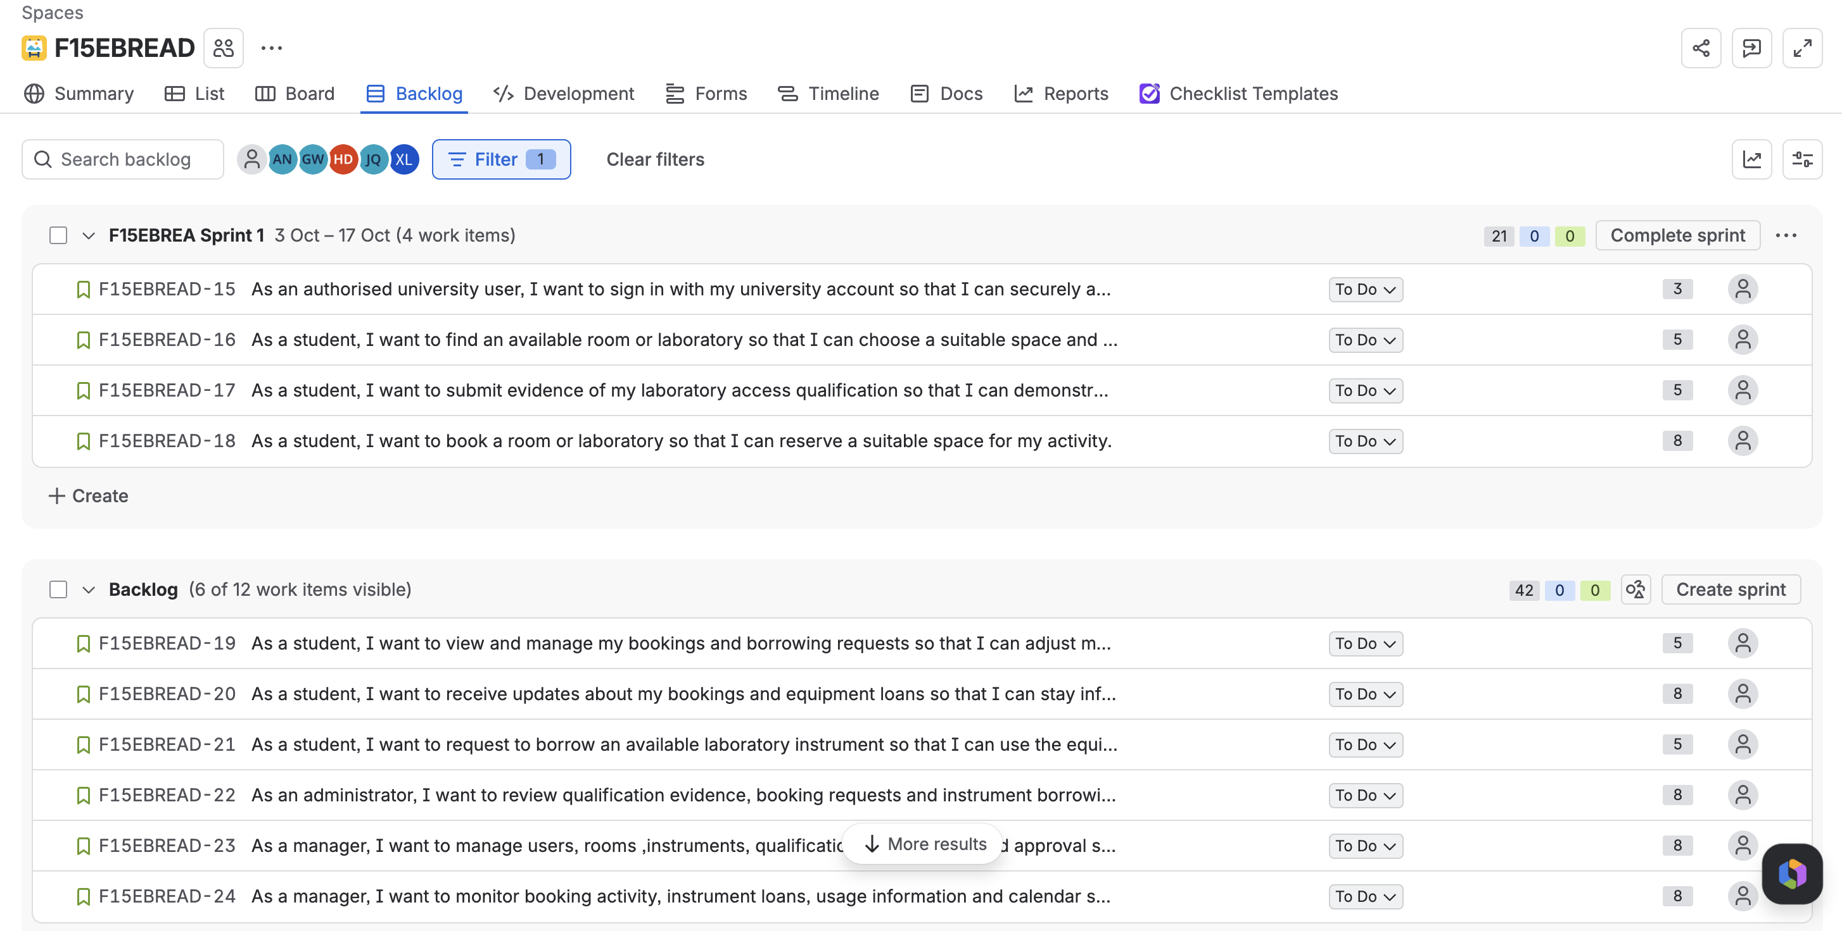
F15EBREAD-19 Manage personal bookings and borrowing requests
User story:
As a student, I want to view and manage my bookings and borrowing requests so that I can adjust my plans.

Acceptance Criteria:
- The student can view current and previous bookings and borrowing requests in a personal dashboard.
- The student can cancel or reschedule their own future booking when the relevant rules allow it.
- The student can cancel their own pending borrowing request.
- A changed booking is checked again for qualification, rules and availability.
- The student cannot view or modify another user’s requests.
Story Points: M

F15EBREAD-20 Receive request updates
User story:
As a student, I want to receive updates about my bookings and equipment loans so that I can stay informed and organized.

Acceptance Criteria:
- The student receives an email notification when a booking or borrowing request is submitted, approved, rejected, cancelled or changed.
- A rejection notification includes the reason for the decision.
- The student receives reminders for an upcoming booking or approaching equipment return date.
- An approved room booking appears in the student’s Outlook calendar and the corresponding room’s Microsoft 365 or Outlook calendar.
- Booking changes or cancellations are reflected in both the student’s and the corresponding room’s calendar events.
Story Points: L

F15EBREAD-21 Request to borrow an instrument
User story:
As a student, I want to request to borrow an available laboratory instrument so that I can use the equipment required for my approved work.

Acceptance Criteria:
- The student can view available instruments and relevant borrowing conditions.
- The student can select an instrument, borrowing period and purpose.
- Any required qualification must be Verified before the request can be accepted.
- A request for an unavailable instrument or invalid period is rejected with a clear reason.
- A valid request receives a reference and a visible approval status.
Story Points: M

F15EBREAD-22 Review qualification, booking and borrowing requests
User story:
As an administrator, I want to review qualification evidence, booking requests and instrument borrowing requests so that only eligible and valid requests are approved.

Acceptance Criteria:
- The administrator can view qualification, booking and borrowing requests waiting for a decision.
- The administrator can mark submitted qualification evidence as Verified or Rejected and can later update, revoke or mark a verified qualification as Expired when necessary.
- The administrator can approve or reject a pending booking or borrowing request.
- Room or instrument availability is checked before a request is approved.
- A rejected request requires a reason that can be viewed by the student.
- The system records the decision and communicates the result to the student.
Story Points: L

F15EBREAD-23 Manage system configuration
User story:
As a manager, I want to manage users, rooms, instruments, qualification requirements and approval settings so that the system reflects current university policies and operational requirements.

Acceptance Criteria:
- The manager can maintain user roles and permissions.
- The manager can create, update, deactivate or temporarily close a room or laboratory.
- When a room or laboratory is temporarily closed, the system identifies affected bookings so that they can be cancelled or rescheduled, and the relevant students are notified.
- The manager can create, update or deactivate an instrument and maintain its availability.
- The manager can specify qualification requirements for restricted laboratories or instruments.
- The manager can configure booking, cancellation and borrowing rules.
- The manager can select automatic approval or administrator review for applicable requests.
Story Points: L

F15EBREAD-24 Monitor system operations
User story:
As a manager, I want to monitor booking activity, instrument loans, usage information and calendar synchronization so that I can ensure the system operates effectively.

Acceptance Criteria:
- The manager can view an overview of users, rooms, instruments and requests.
- The manager can review booking and borrowing history using relevant filters.
- The manager can view basic room and instrument usage information for a selected period.
- The manager can review important approval and configuration changes.
- The manager can view the status of the Microsoft 365 or Outlook integration and identify unsuccessful calendar synchronisation attempts.
- The manager can export a basic usage report in an agreed format.
Story Points: L

